Biblical tour of Greece and 3 day Cruise
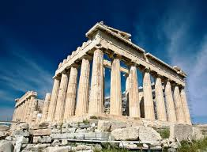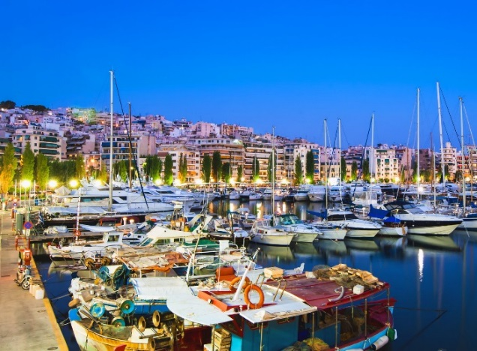

DAY 1 – WEDNESDAY - ARRIVE ATHENS, GREECE
Arrive at Athens Airport where you will be met by our representative and transfer to the hotel. Travel in time, exploring a city with a history of more than 5,000 years!
DAY 2 – THURSDAY – ATHENS & CORINTH
This morning, we depart for our morning tour out of Athens. On the way, we stop at the historic Corinth Canal. It was Corinth (Acts 18:1-18) where Apostle Paul lived and worked, established a thriving church, subsequently sending two of his epistles now part of the New Testament. After visiting the sites associated with Apostle Paul’s ministry, we return to Athens for an afternoon city tour. Climb up to Acropolis Hill to see the famous Parthenon Temple, Erectheion and Temple of Athena Nike. Then walk to nearby Mars’ Hill (Areopagus) (Acts 17:22) where Apostle Paul spoke to the Athenians about the one and only God. Our tour will finish with a panoramic bus tour to see the city highlights. Dinner will be served at hotel.
DAY 3 – FRIDAY - CRUISE TO MYKONOS
After breakfast at the hotel, transfer to Piraeus port for embarkation on the Greek Islands cruise. Sail at 11a.m. and enjoy lunch on board. Our first port of call is Mykonos, where we have free time for walking and exploring the town. Stroll on your own through the whitewashed, flower-decked alleyways, climbing to the sculpture church of Paraportiani or along the waterfront of “Little Venice” to the famous windmills. Enjoy dinner on board and at 11p.m. we sail for Kusadasi, Turkey.
DAY 4 – SATURDAY - KUSADASI (TURKEY) - PATMOS (GREECE)
Arrive at Kusadasi port in Turkey. This is the starting point for our tour to Ancient Ephesus (Acts 18:19-21). Apostle Paul preached to the Ephesians, lived and worked here for a number of years. We tour the spectacular ruins in the city which was founded in the 10th century B.C. After the visit we return to the port for re-embarkation at lunch time and sail to Patmos. Arrive Patmos (Rev 1:9) in the afternoon and enjoy a tour to the Monastery of St. John where he was exiled and wrote the Book of Revelation. We also visit the Grotto of the Revelation (Cave of Apocalypse) before embarking on the cruise ship. Sail to Heraklion, Crete and enjoy dinner on board.
DAY 5 – SUNDAY - CRETE & SANTORINI
At 7 a.m. we arrive at Heraklion, Crete (Acts 27:7-13). You can join the optional excursion to the Minoan Palace of Knossos, home of King Minos and the legendary Minotaur (half-bull and half-man). After a few hours, we sail for Santorini, the island with the most magnificent landscape! Ride the cable car up to the white-washed town of Thera, perched high on the rim of the ancient volcano. Set sail back to the port of Piraeus around 9:00p.m.
DAY 6 - MONDAY - ATHENS - METEORA MONASTERIES - KALAMBAKA
Disembark after breakfast on board. Meet the local guide and board the bus for a journey to Central & Northern Greece! Upon arrival in the town of Kalambaka we enjoy a spectacular drive up to visit two Meteora Monasteries which are built on the top of colossal symmetrical gray and reddish boulders. They are perched precariously high above the ground and they were first built in the 14th century by monks seeking isolation and salvation.
DAY 7 – TUESDAY - BEREA - THESSALONICA
We depart from Kalambaka and continue our journey to Thessalonica. On our way we will stop in Berea (Acts 17:10-15) to see the mosaic monument commemorating Apostle Paul's preaching. Later in the afternoon, check-in at the hotel in Thessalonica. Enjoy the evening at your own leisure. Take a walk by the seaside promenade and explore the beautiful city center.
DAY 8 – WEDNESDAY - PHILIPPI - KAVALA
In the morning, we start for a city tour of Thessalonica. We see the Old City Walls, the White Tower, Galerius Arch and the Rotunda. Continue with a drive to Philippi, the site where Apostle Paul established a strong church. To this congregation he sent his letter (Acts 16:9-33). We see the river where Lydia is said to have been baptized, the ruins of a prison where Apostle Paul and Sylas had been kept, the Agora, 5th and 6th century Basilica and the Theater. After the visit, we continue to Kavala, the ancient port of Neapolis (Acts 16:11) where we enjoy a panoramic tour before returning to Thessalonica for overnight.
DAY 9- 11 - THESSALONICA
Breakfast and dinner at the hotel. Free days.
DAY 12 – THESSALONICA- ATHENS
Group bus transfer to Athens.
DAY 13- ATHENS
Breakfast at the hotel. Free day
DAY 14 – DEPARTURE
The representative of Aristotle Travel transferrin you to Athens International Airport “Eleftherios Venizelos” for your departure flight.

